**Containerize The App**

**Date** 08 November 2022

**Team ID** PNT2022TMID15761

**Project Name** Smart Fashion Recommender Application

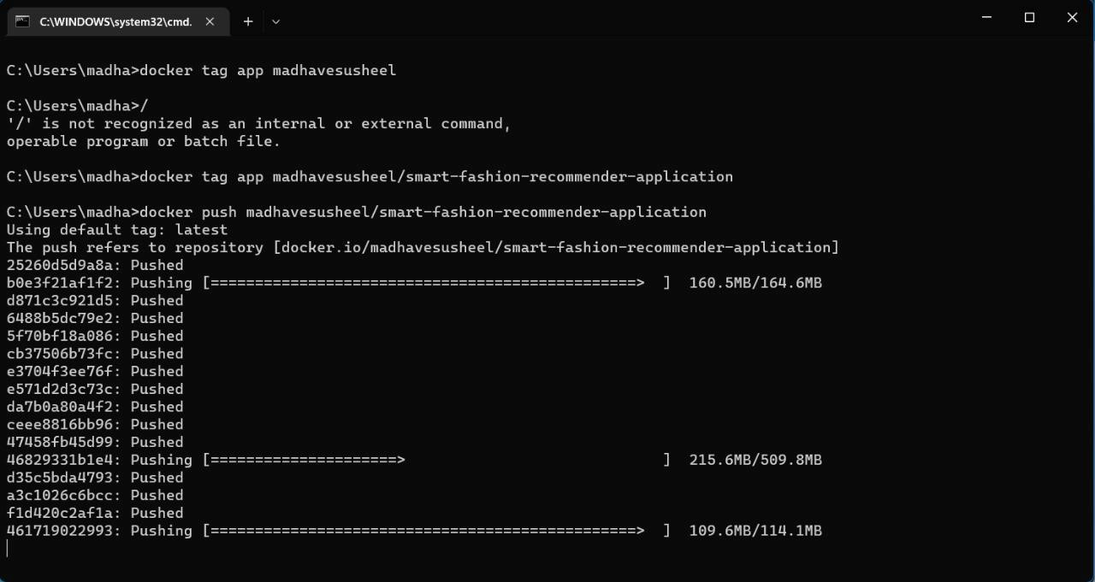

**DOCKER PUSH:**

**CONTAINERIZING THE APPLICATION:**

